- A big fall in UK government spending on debt interest in December, aided by lower inflation, pushed down public borrowing. But the prospect of a smaller than expected deficit this year is of limited relevance for medium-term fiscal space. And other developments have narrowed hoped-for headroom against the government's fiscal rules. Still, tax cuts in March's Budget remain likely.
- Meanwhile, January's S&P Global/CIPS survey signalled that the economy began 2024 on a firmer footing, although there were mixed signals on inflationary pressures. This reinforces our view that the MPC will be circumspect about the prospect of rate cuts when it meets next week.
With the next general election due within the next 12 months, the forthcoming Budget on March 6 will potentially be the last fiscal event before the UK goes to the polls. That Chancellor Jeremy Hunt wants to use the Budget to deliver tax cuts was clear in comments he made at Davos last weekend, with Hunt arguing that low tax economies tended to be more dynamic. And taken in isolation the latest public borrowing numbers, which showed a big deficit undershoot in December compared to expectations, present a positive outlook for the Chancellor's Budget planning.
Net borrowing of £7.8bn compared with £16.2bn a year earlier, when government spending was inflated by the cost of energy support payments. December's outturn also came in well below the Office for Budget Responsibility's forecast of £14bn. Key to the downside surprise was a sharp decline in spending on debt interest, as a faster-than-expected fall in RPI inflation cut the cost of servicing inflation-linked gilts.
The UK's public finances, with an unusually large share of debt linked to inflation compared to other major economies, were particularly exposed to the jump in inflation during 2021 and 2022. But the fall in the RPI measure (from a peak of 14.2% in October 2022 to 5.2% last December) means what was a major headwind to a lower deficit has become a tailwind (Chart 1). Combined with a £5bn downward revision to borrowing earlier in 2023-2024, December's outturn left the deficit in the fiscal year to date at £119.1bn, £4.9bn lower than the OBR's forecast. With falling inflation set to weigh on debt interest spending further, there's a good chance that borrowing in 2023-2024 will come in below the OBR's projection of £123.9bn.
Chart 1: Spending on debt interest has fallen back
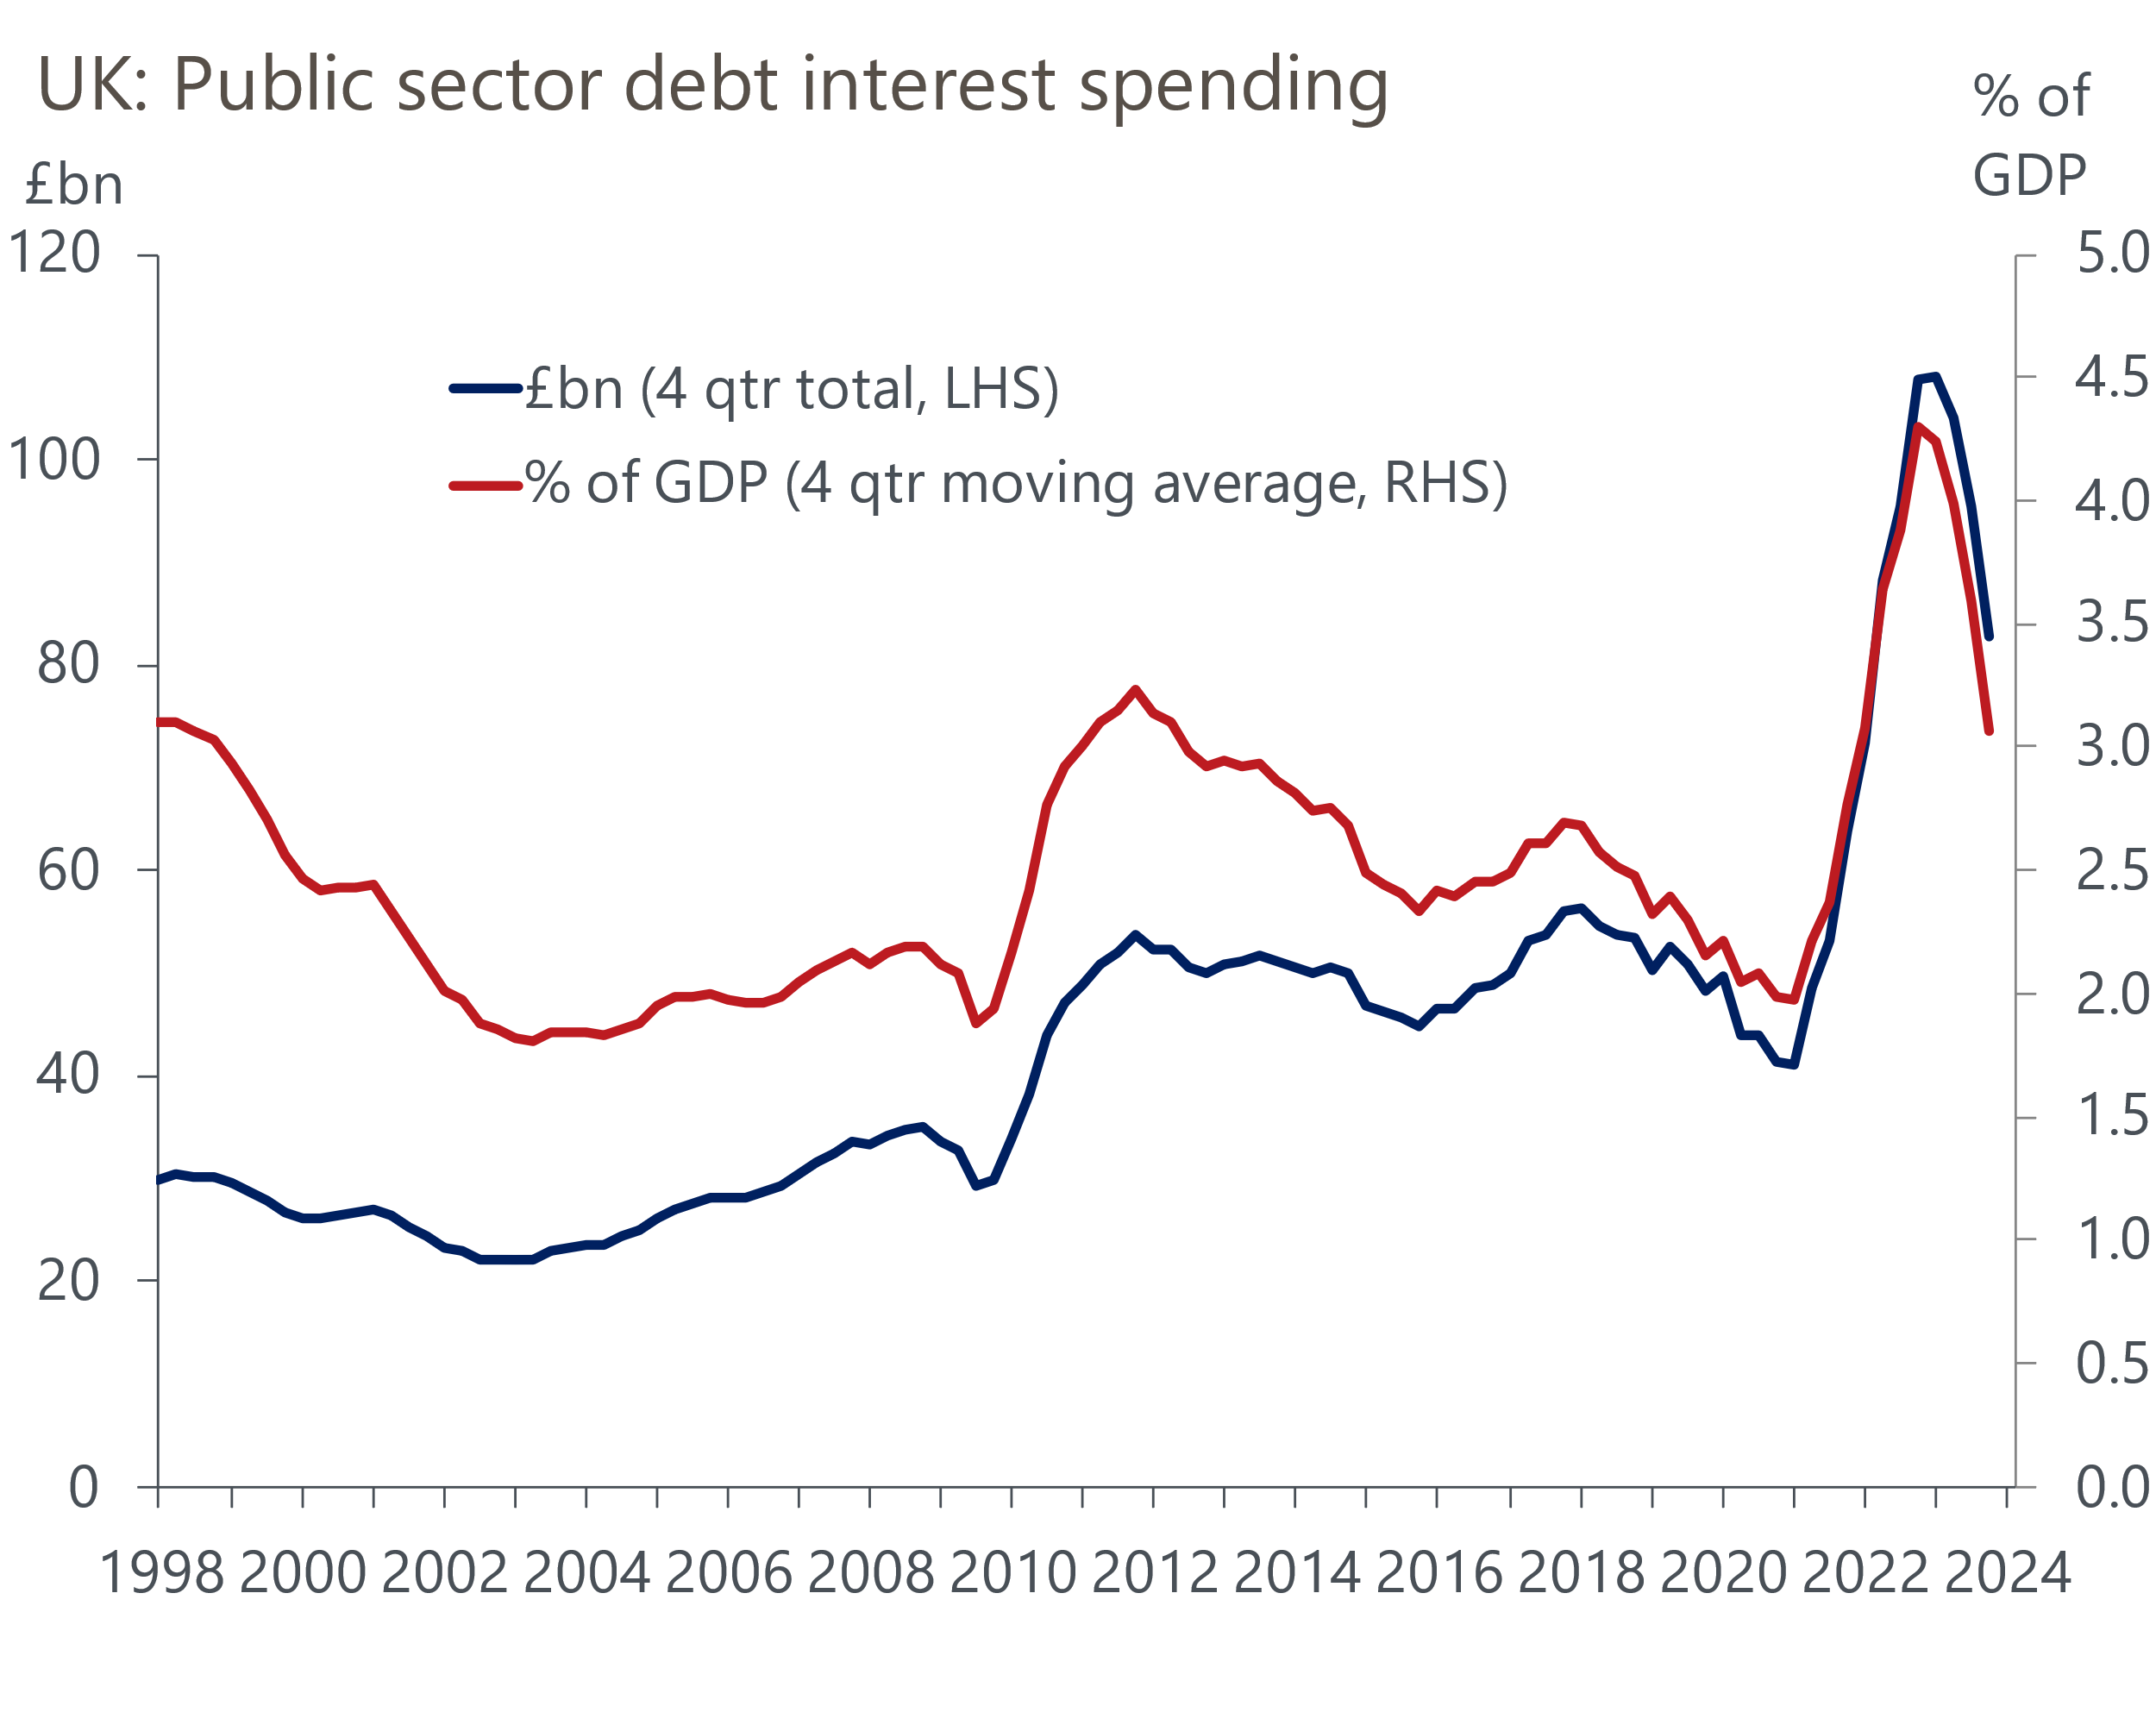
Source: Oxford Economics/Haver Analytics

However, what happens in the current fiscal year is of only limited relevance for the government's fiscal rules, which are centred on five years in the future. In some respects, the medium-term outlook looks better than the OBR previously thought due to the drop in market interest rate expectations over the last few months. However, investors have recently scaled back predictions of how far the BoE will cut rates over the medium-term. And falling inflation is not an unalloyed fiscal blessing. It will weigh on projected receipts from VAT, since prices in the shops are rising less quickly. Income tax receipts could also be hit if the OBR assumes softer future pay growth, meaning the gain from the current cash freeze in thresholds is less.
As a result, the Treasury has reportedly warned the Chancellor that headroom against his fiscal goals may not be much bigger than projected in November. Still, given the government's current poor opinion polling, it's likely that Hunt will use whatever fiscal space he has for tax cuts.
The nature and scale of any cuts will have a bearing on the Bank of England's interest rate decisions. On the subject, we expect next week's meeting of the Monetary Policy Committee to see a softening of previous 'bias to hike' rhetoric. But most members of the committee will probably want more reassurance on wage and price pressures before supporting a cut in rates.
Caution on the part of most MPC members is likely to be bolstered by January's flash S&P Global/CIPS survey. Rising shipping rates, connected to troubles in the Red Sea, contributed to manufacturers' input costs rising at the fastest pace since March 2023. The survey also noted ongoing cost pressures for services firms, linked mainly to strong pay growth. That said, these pressures eased compared to the last few months, resulting in growth in prices charged by private sector firms slipping to a three-month low.
On the activity side, January's survey suggested the economy began 2024 on a stronger footing, another reason why the MPC is unlikely to be gung-ho in signalling rate cuts. The flash composite PMI rose to a seven-month high of 52.5 from December's 52.1. According to the survey, the economy's dominant services sector continued to outperform manufacturing. A flash services PMI of 53.8 was up from 53.4, but the output balance of the manufacturing survey fell to a three-month low of 44.9 from 45.5. The downbeat message from the latter tallied with January's weak industrial survey from the CBI, while the CBI's survey of retail activity, a sector that isn't covered by S&P Global/CIPS, was also soft.
January's PMI is consistent, based on past form, with GDP growth picking up in Q1 from what looks to have been stagnation, or a small contraction, in the final quarter of 2023 (Chart 2). But another round of junior doctor strikes at the start of this month means industrial action in the public sector – a factor not captured in business surveys – will likely weigh on the ONS' official measure of output in January.
Chart 2: January's composite PMI moved further into expansionary territory
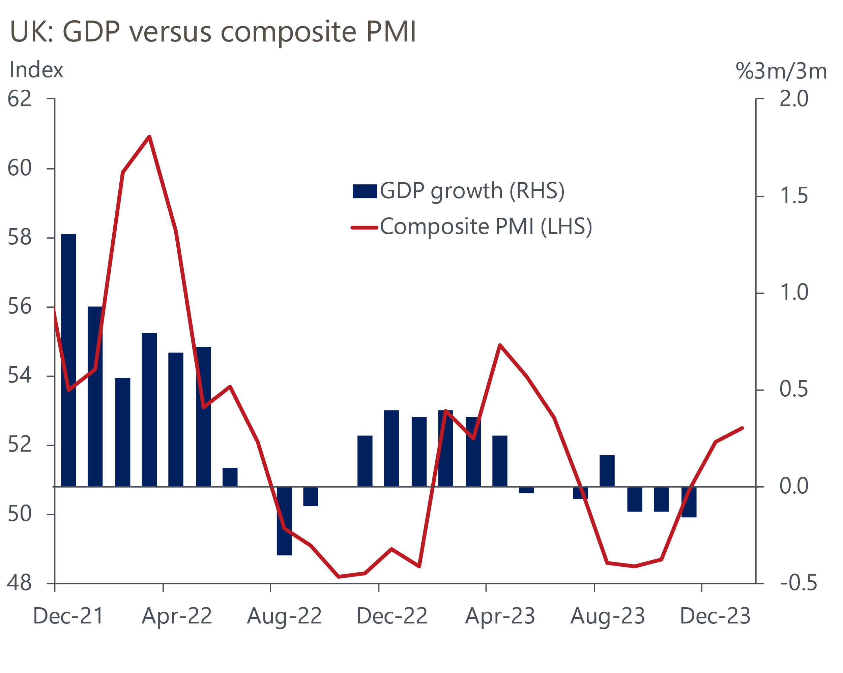
Source: Oxford Economics/S&P Global/CIPS
Nonetheless, the latest PMI offers some early support to our expectation that lower inflation will allow the economy to gradually build momentum this year.

The week ahead
Next week's MPC meeting is likely to be the fourth in succession to keep Bank Rate unchanged at 5.25%. But with the BoE set to significantly cut its forecast for inflation, we expect a more united committee, with some of those who voted for a hike in December falling into line with the consensus. A less worrying inflation outlook means the MPC is likely to soften previous 'bias to hike' rhetoric. But we think most members of the committee will make clear that they want more reassurance on wage and price pressures before supporting a cut in Bank Rate.
Data from the BoE on household lending is likely to show the gradual recovery in mortgage activity in late 2023 continued in the final month of last year. Quoted mortgage rates fell further in December, adding to earlier declines. We think this will have helped support a rise in mortgage approvals to around 52,000 from just over 50,000 in November. Meanwhile, the pick-up in mortgage approvals last autumn suggests net mortgage lending returned to modestly positive territory in December.
Net unsecured lending jumped in November, rising to the highest level in almost seven years. Given November's unexpected strength and the weakness of retail sales in December, we expect net lending via credit cards and personal loans to have fallen back to £1.3bn in December from £2bn in November.
January's flash manufacturing PMI pointed to a sector stuck in the doldrums, and there's no reason to think the final PMI will tell a different story. The flash index of 47.3 was higher than December's 46.2, but this was driven by a lengthening in suppliers delivery times, as shipping was disrupted by troubles in the Red Sea. We expect a final PMI of 47.5.
Table 1: Week ahead calendar
Date | Events | Period | Measure | Unit | Previous | Forecast
Jan 30 | Mortgage approvals | Dec | Level | 000s | 50.1 | 52.0
Jan 30 | Mortgage lending | Dec | Net lending | £bn | 0.0 | 0.4
Jan 30 | Consumer credit | Dec | Net lending | £bn | 2.0 | 1.3
Jan 31 | Nationwide house prices | Jan | m/m | % | 0.0 | 0.1
Jan 31 | Nationwide house prices | Jan | y/y | % | -1.7 | -0.9
Feb 1 | S&P Global/CIPS manufacturing | Feb | PMI | % bal | 47.3 | 47.5
Feb 1 | BoE Bank Rate decision | Feb | Bank Rate | % | 5.25 | 5.25
Source: Oxford Economics

Key forecasts
Table 2: UK forecast overview
(Annual percentage changes unless specified)
 | 2021 | 2022 | 2023 | 2024 | 2025 | 2026
GDP | 8.7 | 4.3 | 0.3 | 0.6 | 1.6 | 1.9
Private consumption | 7.5 | 4.8 | 0.6 | 0.9 | 1.8 | 1.9
Fixed investment | 7.4 | 8.0 | 2.3 | -3.2 | 0.5 | 2.8
Government consumption | 14.9 | 2.3 | 0.6 | 4.3 | 2.1 | 1.6
Exports of goods and services | 4.9 | 9.0 | -0.3 | 0.1 | 2.8 | 2.4
Imports of goods and services | 6.1 | 14.6 | -1.3 | 2.0 | 3.3 | 3.0
Industrial Production | -3.9 | -3.5 | -0.4 | 0.4 | 0.9 | 1.5
Consumer prices | 2.6 | 9.1 | 7.3 | 2.1 | 1.5 | 1.8
Unemployment rate (%) | 4.5 | 3.7 | 4.1 | 4.5 | 4.3 | 4.0
Current a/c balance (% of GDP) | -0.5 | -3.1 | -2.6 | -2.5 | -2.6 | -2.7
Government balance (% of GDP) | 7.2 | 4.4 | 5.4 | 3.3 | 2.9 | 2.4
Cen. bank policy rate (%, EOP) | 0.25 | 3.50 | 5.25 | 4.25 | 3.25 | 2.25
10yr govt. bond yield (%, EOP) | 0.97 | 3.67 | 3.54 | 3.59 | 3.37 | 2.92
Exchange rate (US$ per £, EOP) | 1.35 | 1.20 | 1.27 | 1.26 | 1.28 | 1.31
Exchange rate (euro per £, EOP) | 1.19 | 1.13 | 1.15 | 1.16 | 1.15 | 1.15
Source: Oxford Economics
Table 3: Quarterly forecasts for the UK
 | 2023 |  |  |  | 2024
 | Q1 | Q2 | Q3 | Q4 | Q1 | Q2 | Q3 | Q4
GDP (% year) | 0.4 | 0.3 | 0.3 | 0.2 | 0.2 | 0.4 | 0.8 | 1.0
CPI inflation (% year) | 10.2 | 8.4 | 6.7 | 4.2 | 3.7 | 1.6 | 1.6 | 1.5
Bank Rate (%, EOP) | 4.25 | 5.00 | 5.25 | 5.25 | 5.25 | 4.75 | 4.50 | 4.25
10yr gilt yield (%, EOP) | 3.47 | 4.39 | 4.46 | 3.54 | 3.75 | 3.64 | 3.61 | 3.59
US$ per £ (EOP) | 1.24 | 1.27 | 1.22 | 1.27 | 1.25 | 1.25 | 1.25 | 1.26
Euro per £ (EOP) | 1.14 | 1.17 | 1.15 | 1.15 | 1.16 | 1.16 | 1.16 | 1.16
Source: Oxford Economics

Latest Country Economic Forecast:
January 18, 2024

Recent publications

Data Insights
Flash PMIs suggest economy began 2024 on a better footing
December's fiscal deficit was well below expectations
Don't read too much into December's retail sales data
Inflation set to fall sharply despite December's upside surprise
Pay growth continues to cool

Research Briefings
Housing market on course for a soft landing
MPC preview – A change of tone, but not of policy
Nowcast points to continued labour market resilience
Will the MPC cut fast or slow?
The boost from falling rates will be a slow-burner

Contacts

Oxford Economics' UK team
- Andrew Goodwin - Chief UK Economist - agoodwin@oxfordeconomics.com
- Edward Allenby - UK Economist - eallenby@oxfordeconomics.com

